1. **Create one jenkins job using the below code and create three stages. stage1: Git clone to download the source code.**

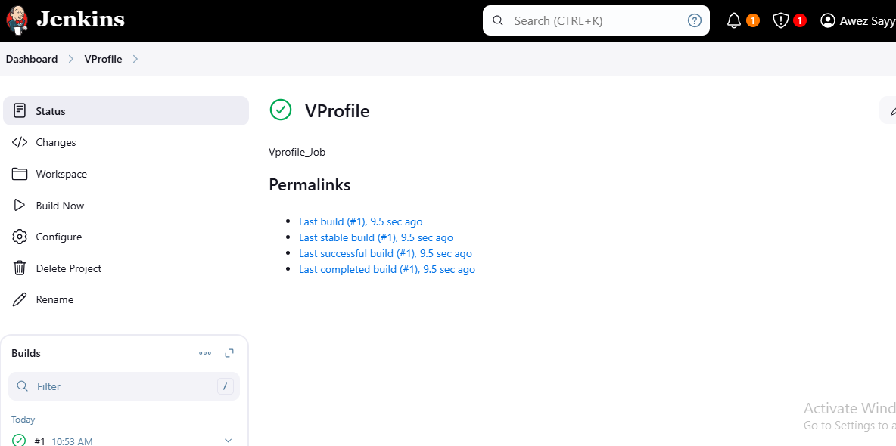

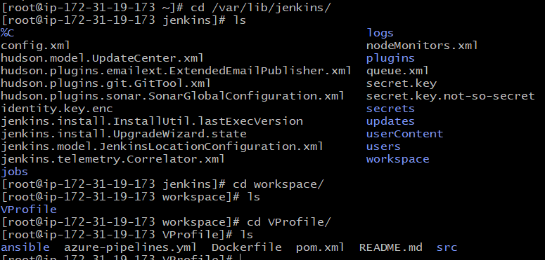

**stage2: Sonarqube Integration to check the quality of code**

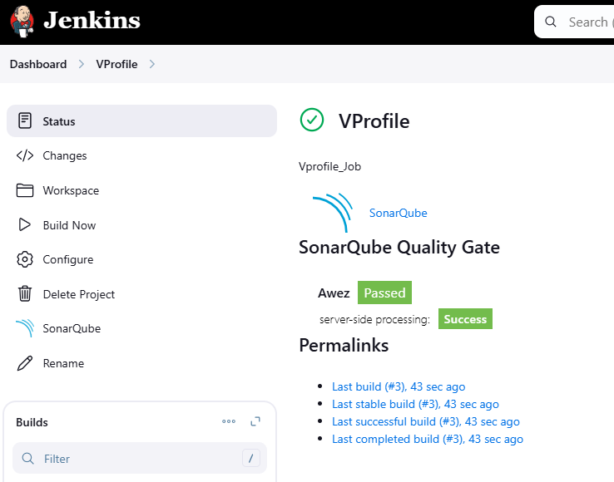

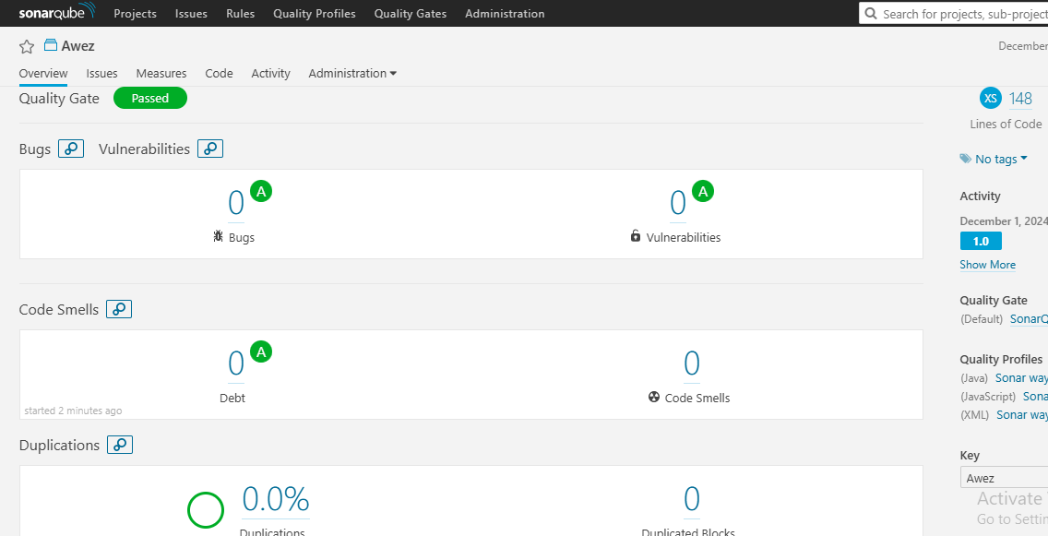

**stage3: Slack Integration to send the alerts to slack. URL:** [**https://github.com/betawins/VProfile-1.git**](https://github.com/betawins/VProfile-1.git)

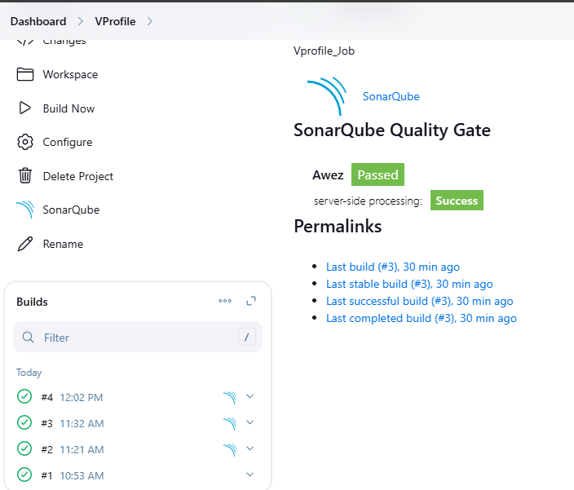

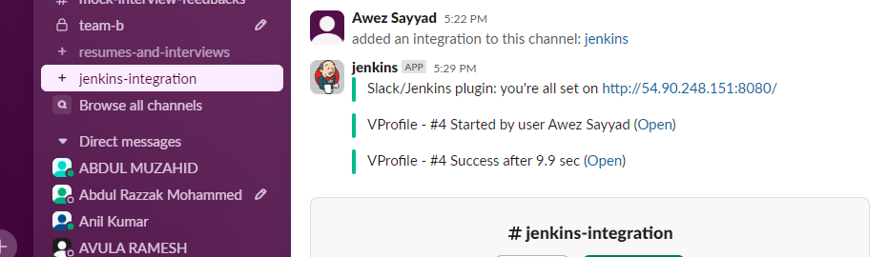

1. **1) Create one jenkins job using the below code and create three stages.**

**stage1: Git clone to download the source code.**

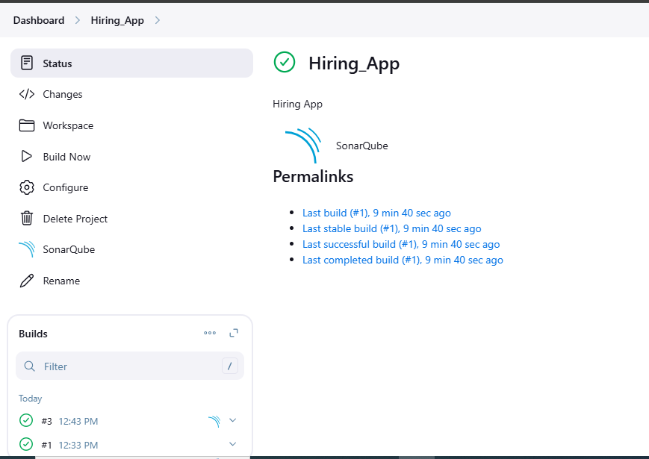

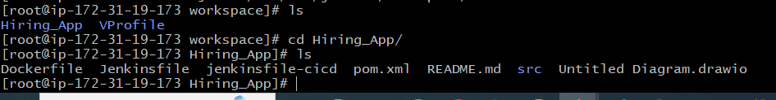

**stage2: Sonarqube Integration to check the quality of code**



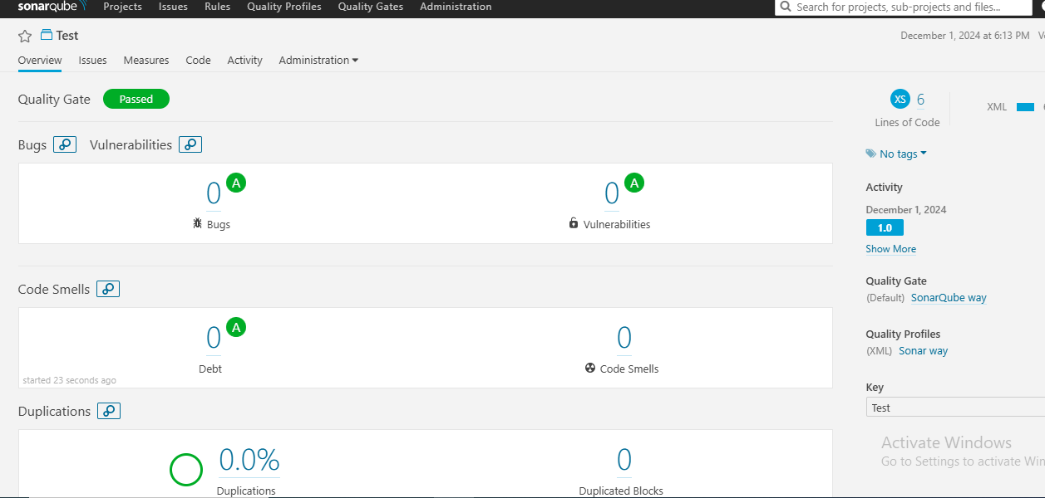

**stage3: Slack Integration to send the alerts to slack. URL:** [**https://github.com/betawins/hiring-app.git**](https://github.com/betawins/hiring-app.git)

